**Readme.P1**

1, To create tables :

**db2 -tvf p1_create.sql**

It creates two tables: p1.customer and p1.account.

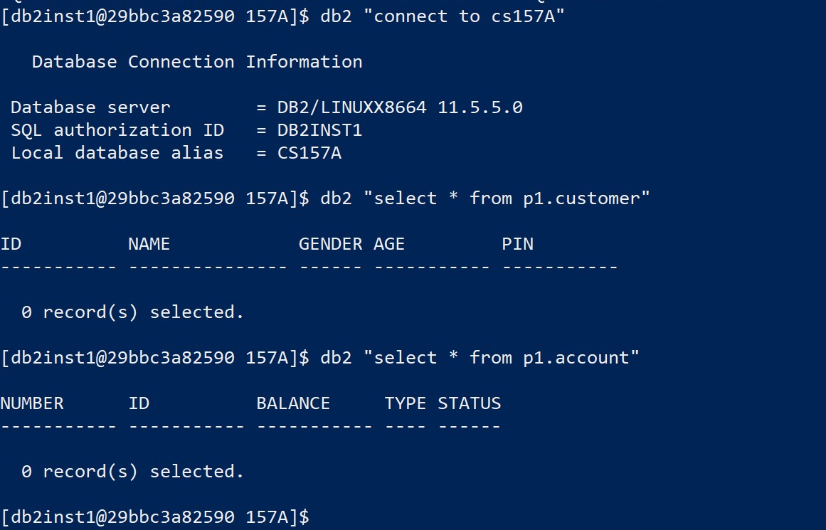

2, To create original records for the tables and check the methods in BankingSystem.java.

C:\java\p1_test\src>**javac *.java**

C:\java\p1_test\src>**java -cp ";.\db2jcc4.jar" ProgramLauncher .\db.properties>test1.out**

After running the above commands in Java, we can check some records are created. And a file **test1.out** is created. Its content is similar to **test_full.out**. It means all the methods in BankingSystem.java run well.

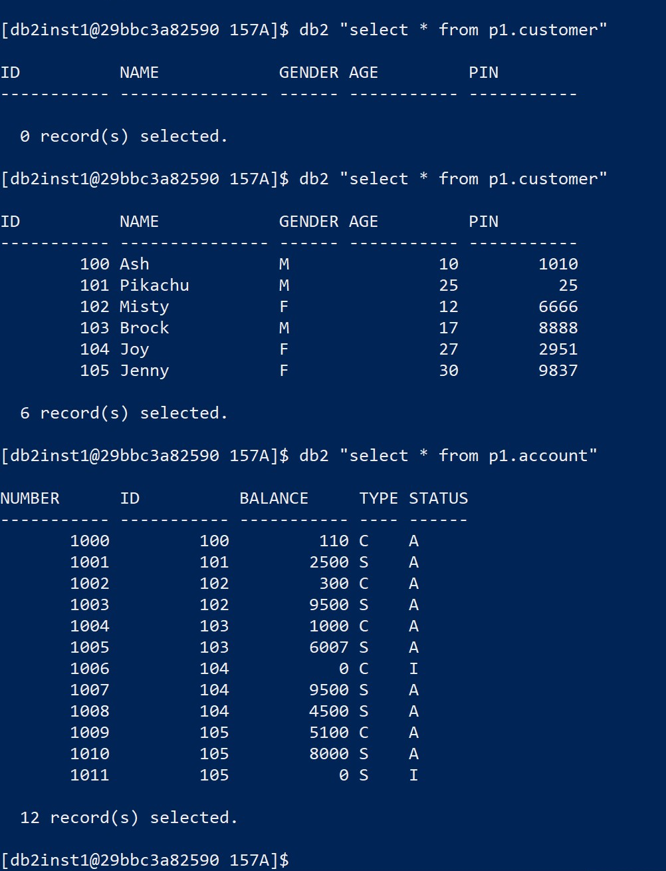

3, Begin to test P1.java

C:\java\p1_test\src>**java -cp ";.\db2jcc4.jar" P1 .\db.properties**

3.1, Screen#1.1---**To create a new customer**.

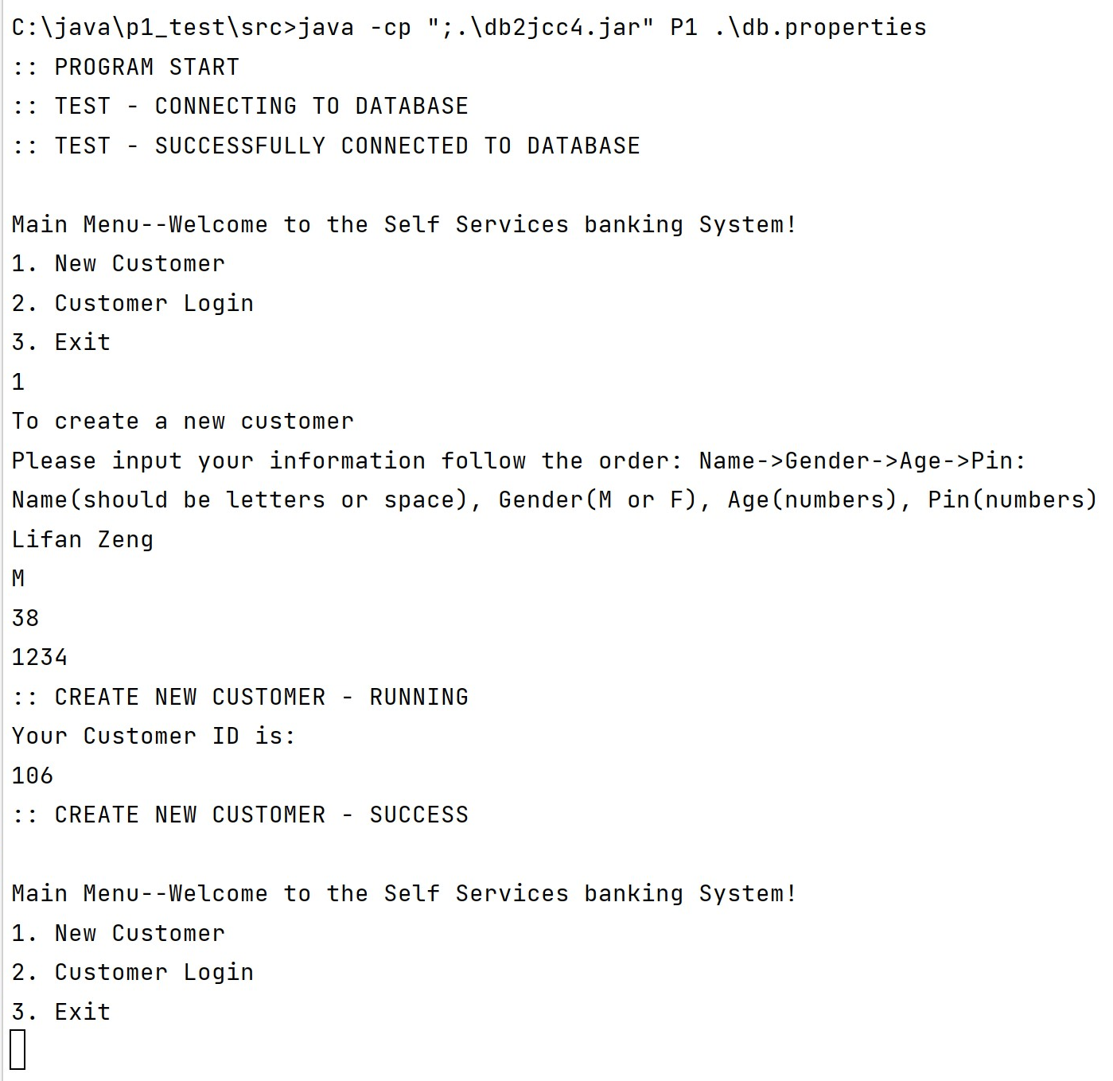

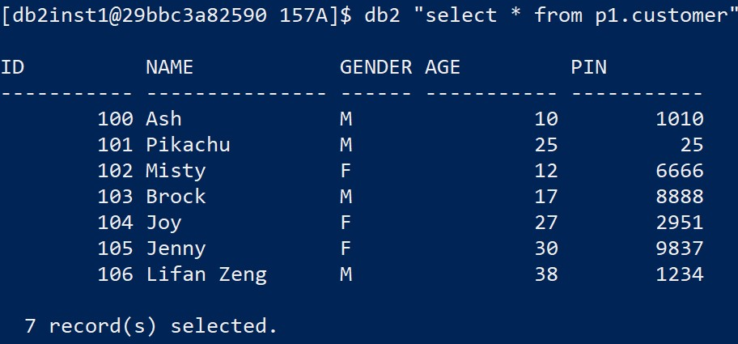

Screen#1.2---**Customer** **login** **& Exit**

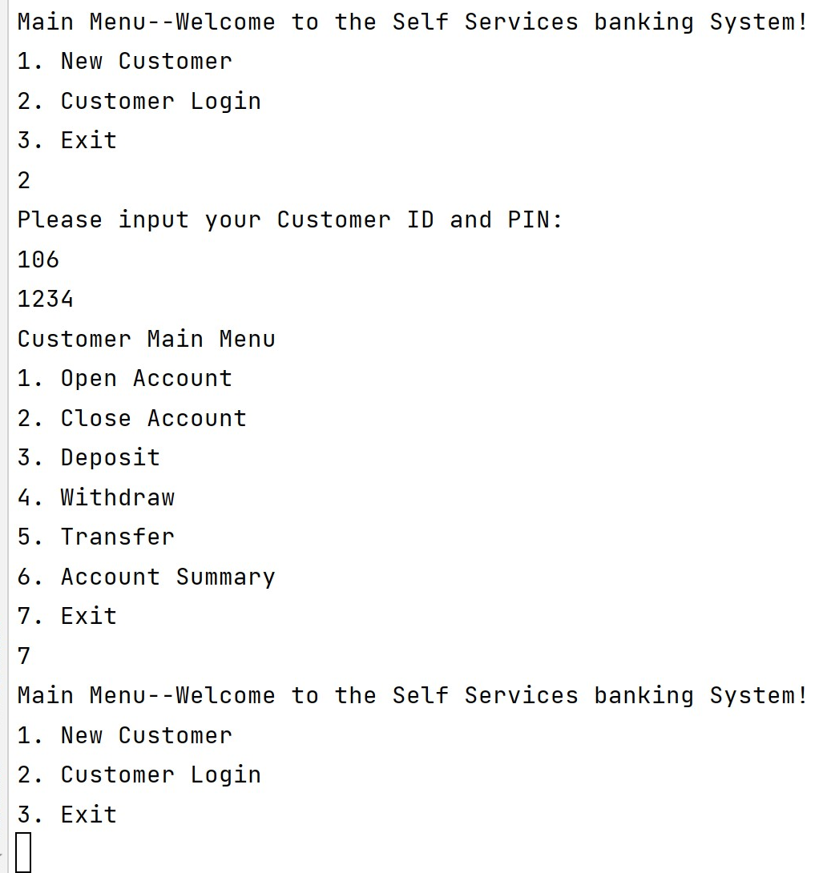

3.2, Screen #3

Screen 3.1---**Open account**

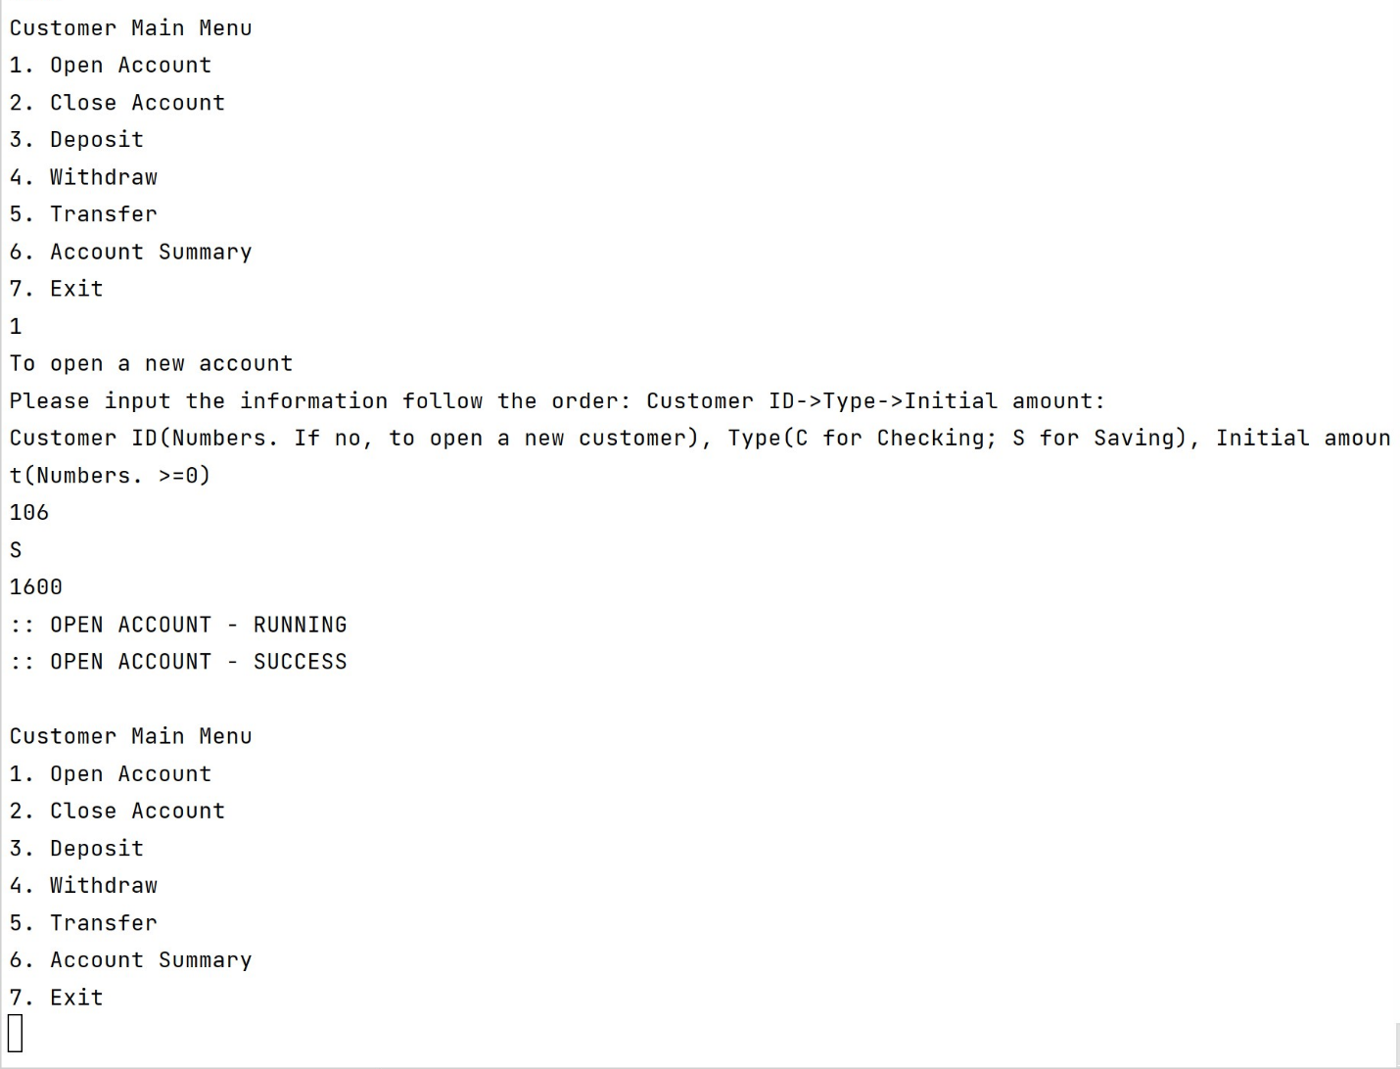

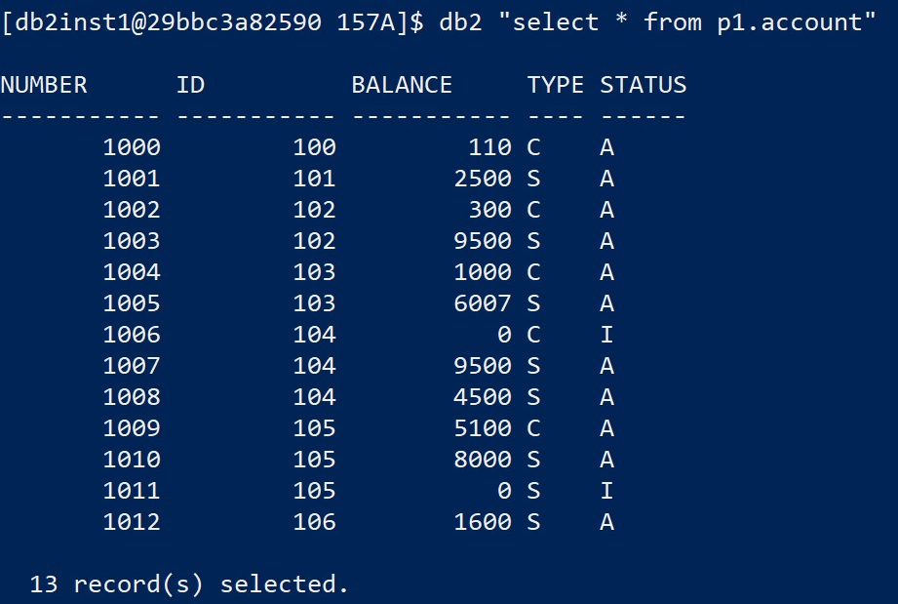

Screen 3.1---**Close account**

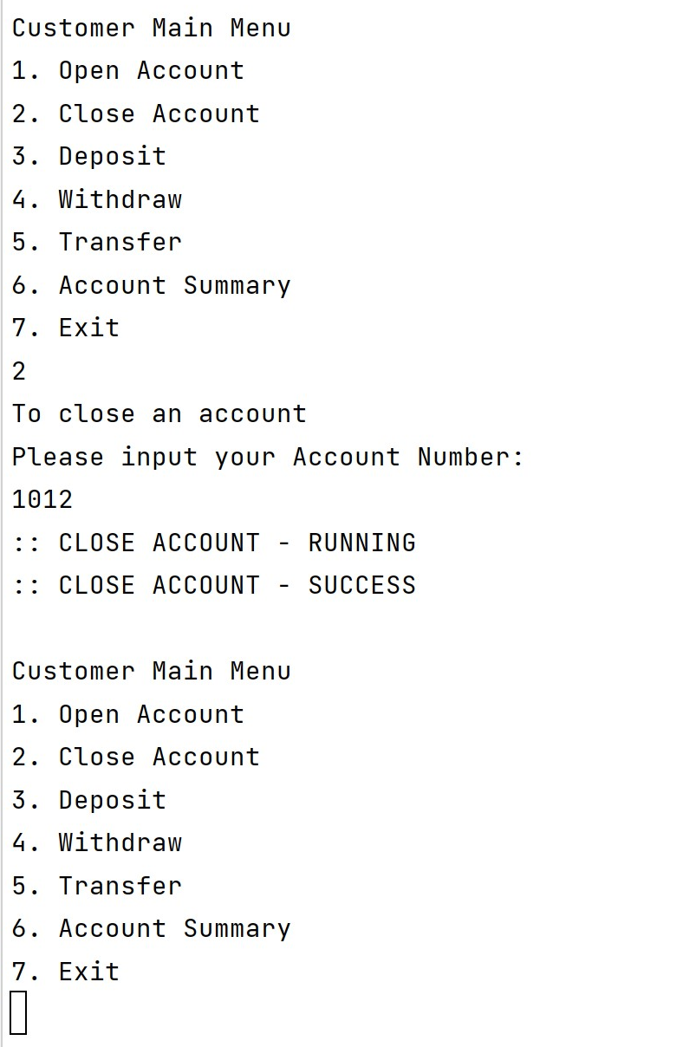

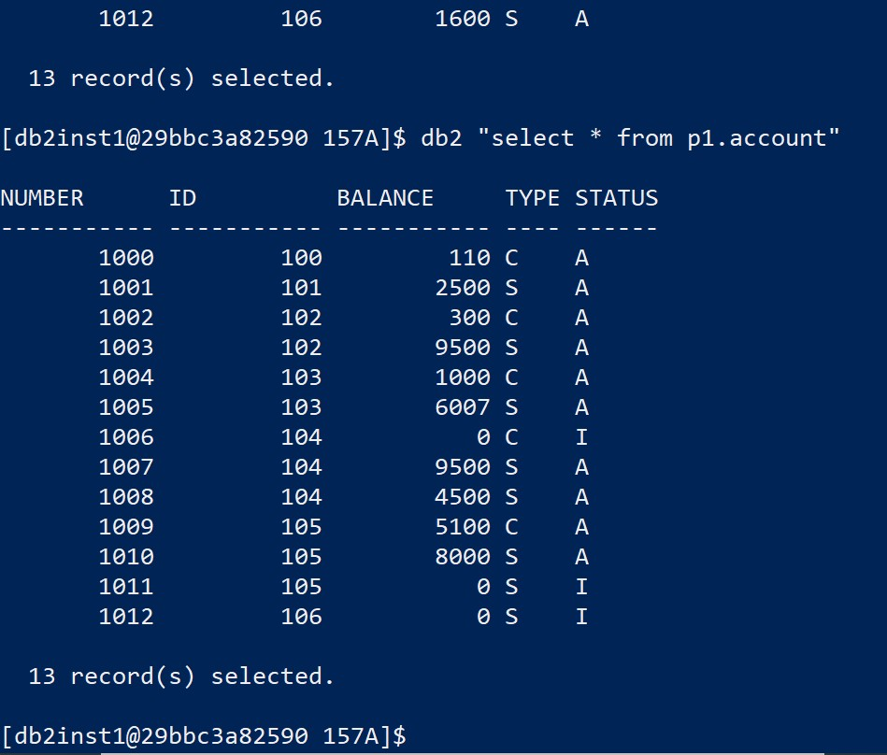

Screen 3.3---**Deposit (**create new account 1013 for 106, then deposit 2000**)**

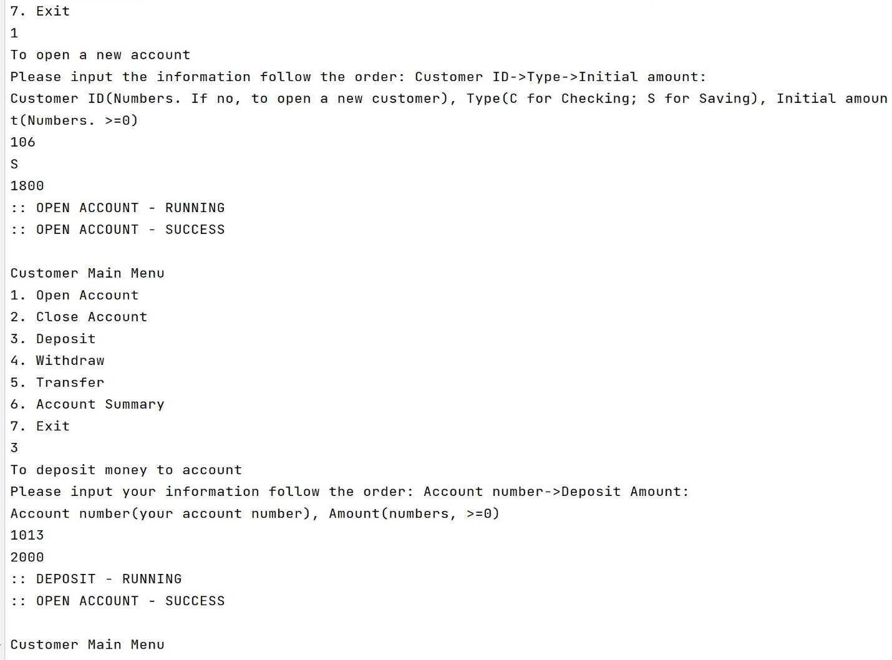

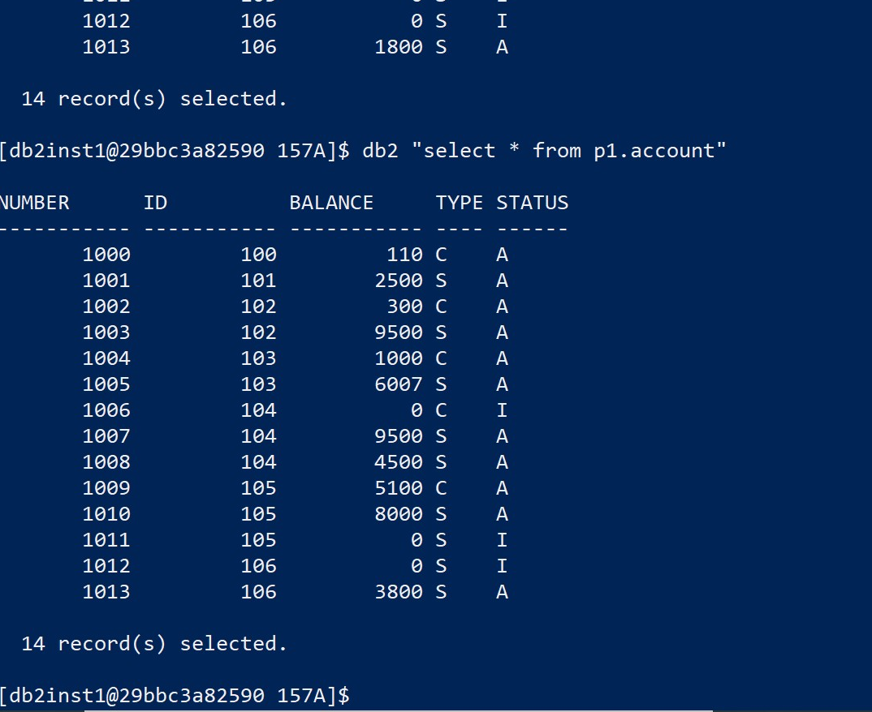

Screen 3.4---**Withdraw**

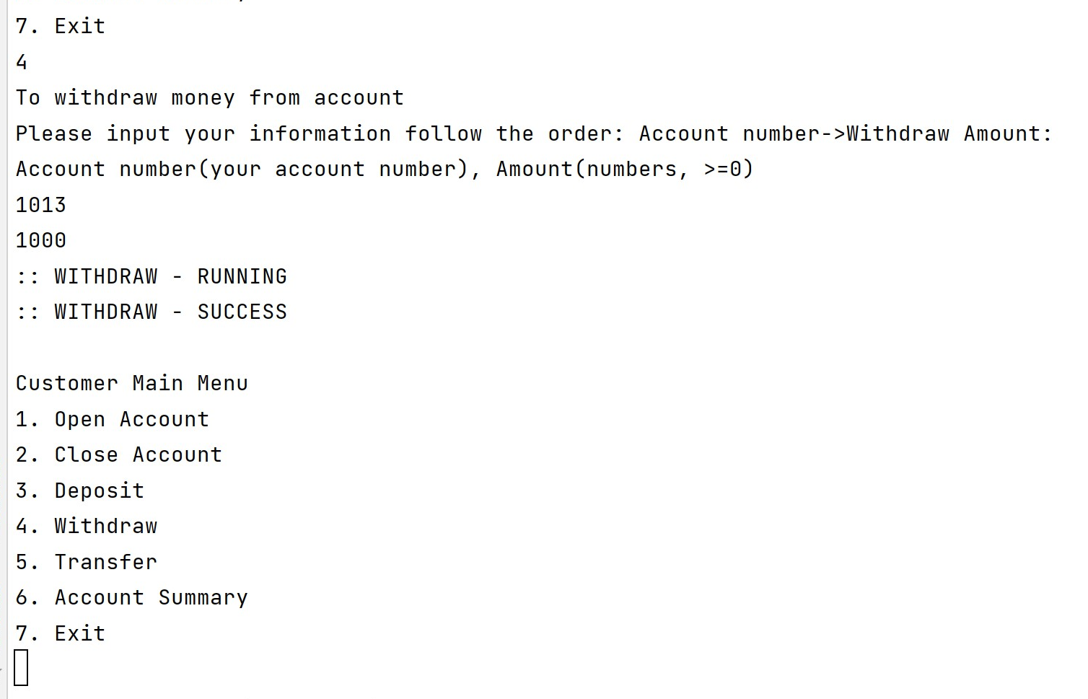

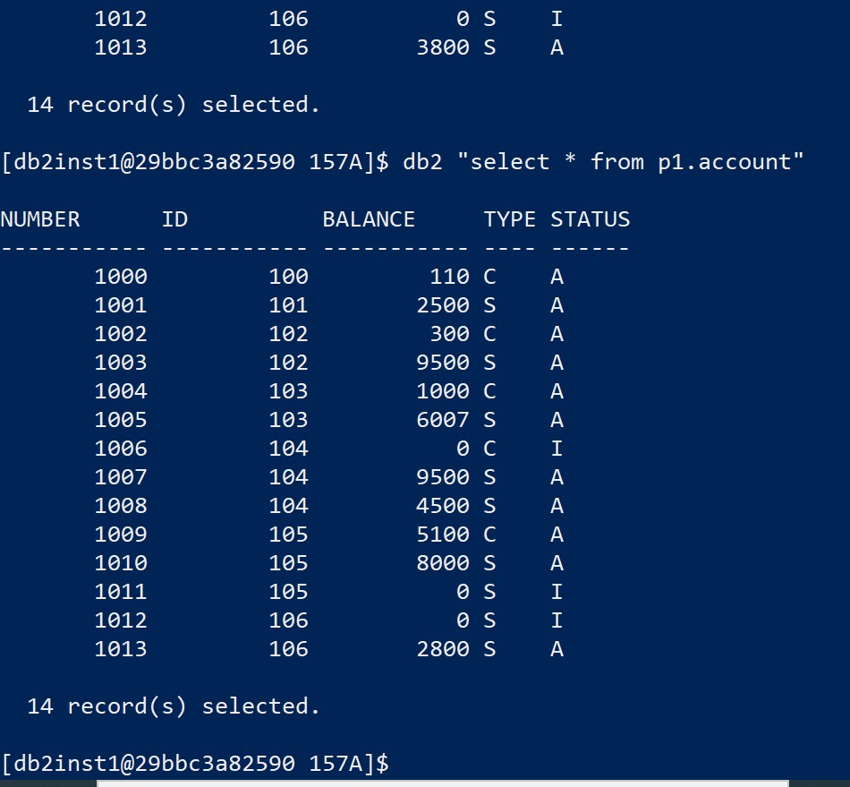

Screen 3.5---**Transfer (** From 1013 to 1010, transfer 800**)**

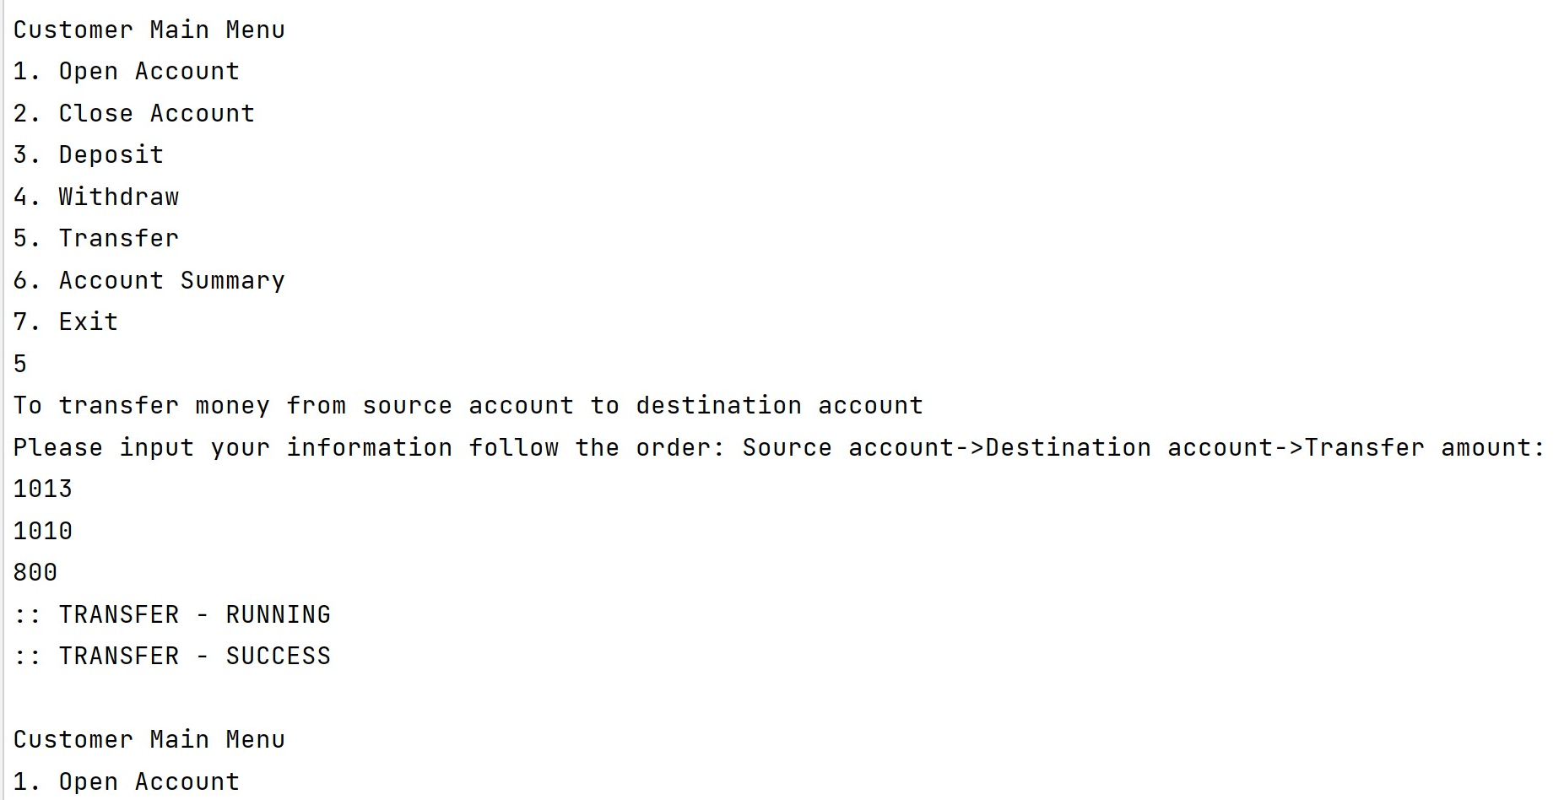

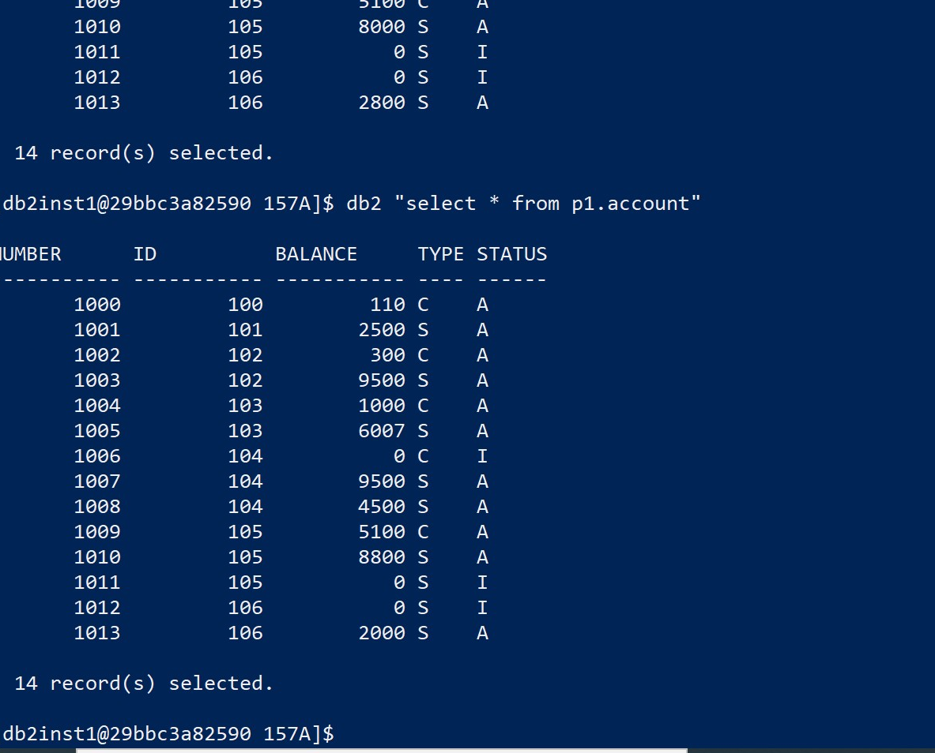

Screen 3.6---**Display all accounts**

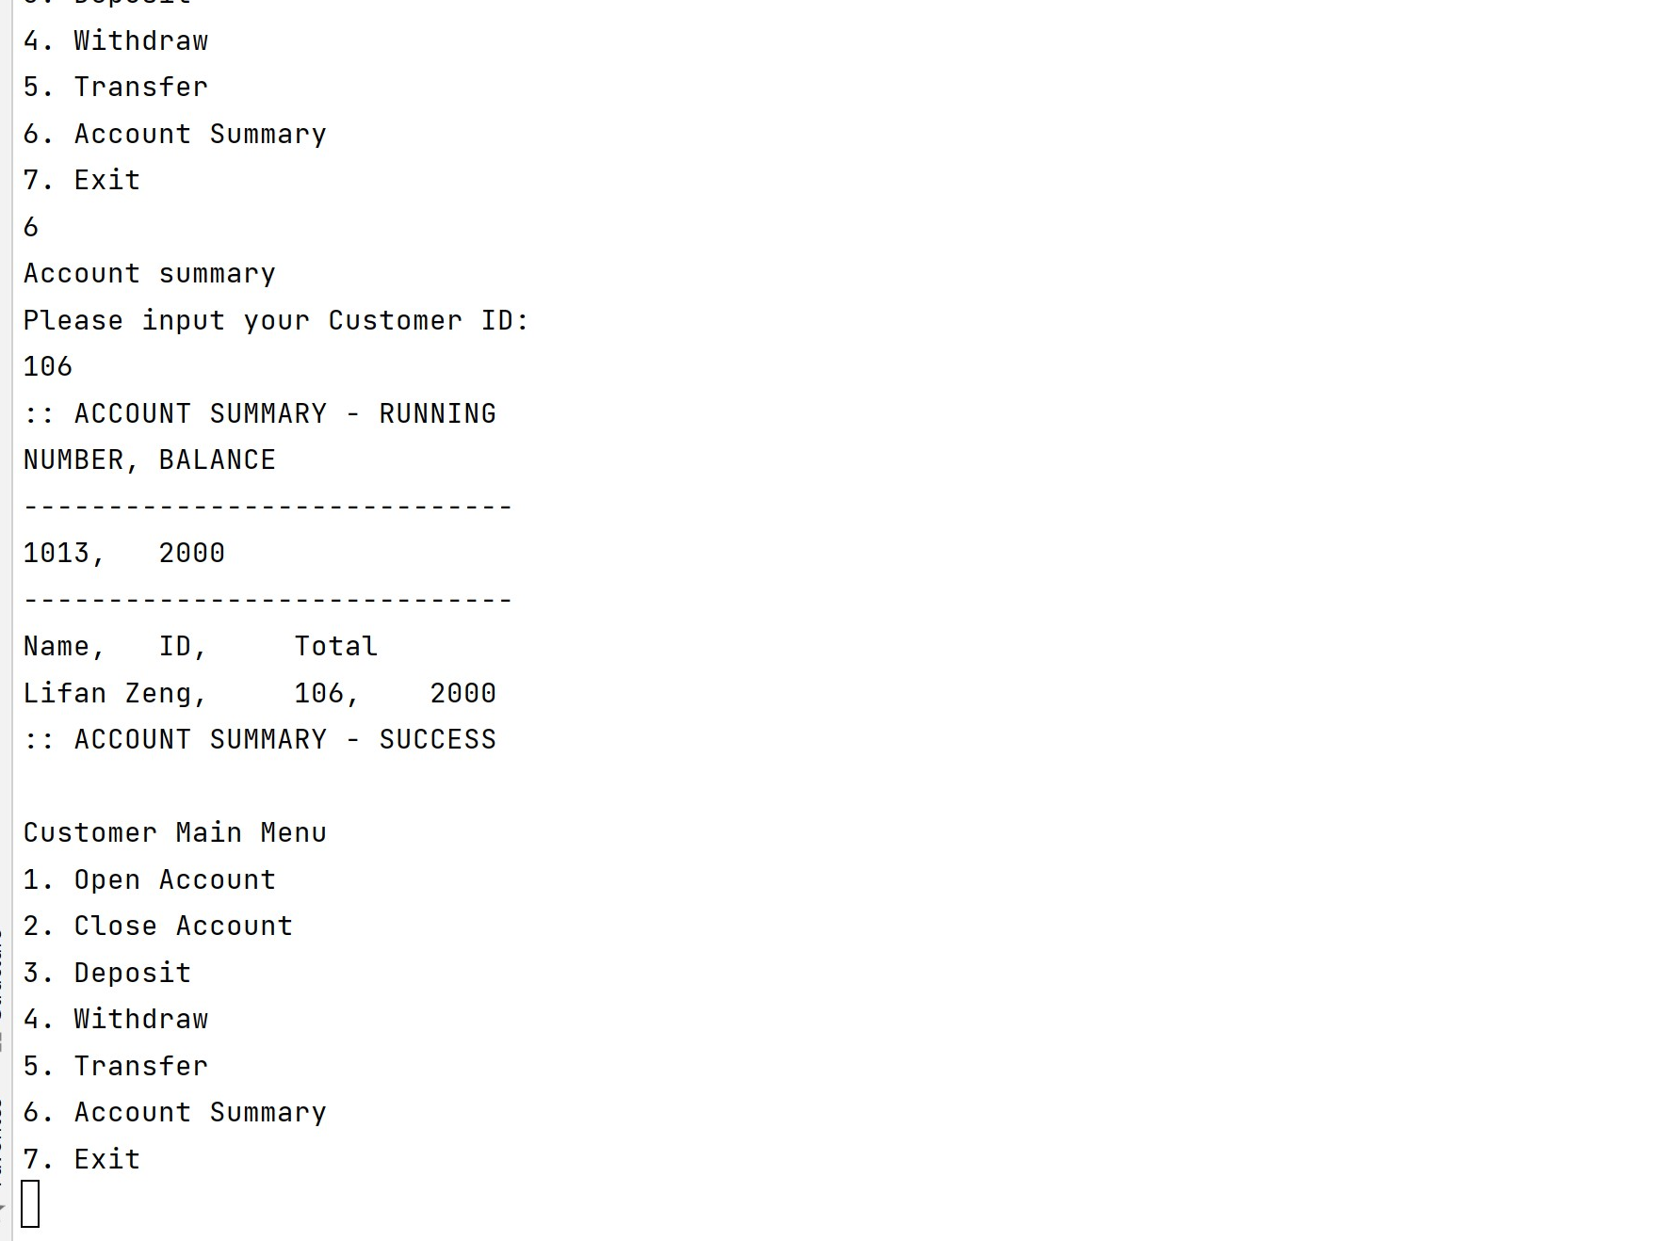

The other functions, please run the program.